# Exercise 7.4

## Problem Statement

Generate random variables from a standard normal distribution that will serve as the random sample. Determine the jackknife estimate of the standard error for XBar, and calculate the bootstrap estimate of the standard error. Compare these to the theoretical value of the standard error.

## Code

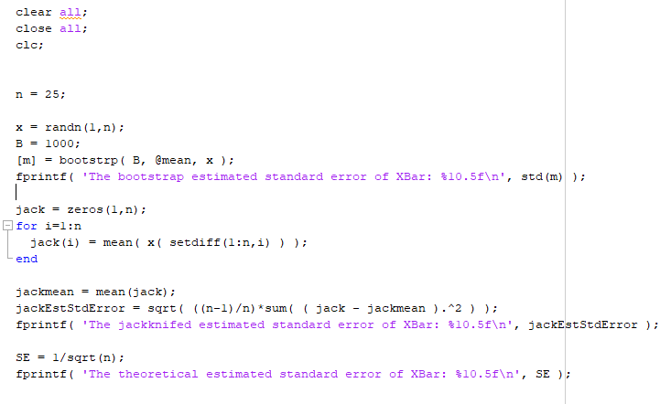

## Results



## Discussion

The theoretical value of the standard error of the sample mean for a standard normal distribution is 1/sqrt(N). Our bootstrap and jackknifed estimates of the standard errors are very close to the theoretical value.

# Exercise 7.5

## Problem Statement

Using a sample size of n = 15 , generate random variables from a uniform (0,1) distribution. Determine the jackknife estimate of the standard error for xbar, and calculate the bootstrap estimate of the standard error for the same statistic. Let’s say we decide to use as an estimate of the standard error for . How does this compare to the other estimates?

## Code

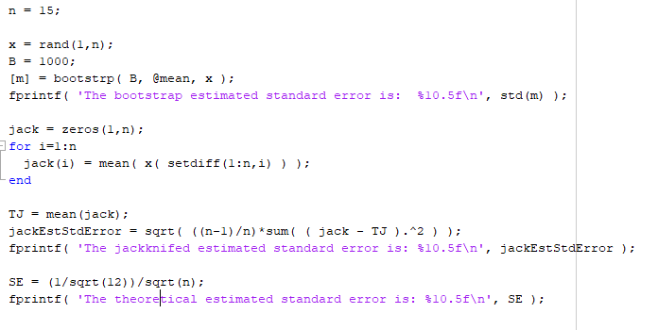

## Results

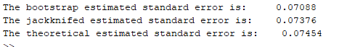

## Discussion

The same procedure was used as in 7.4. The theoretical variance of the standard uniform is 1/12. Using the book’s suggestion we arrived at a theoretical estimate for the standard error. Once again our bootstrap and jackknife estimates are very close to the theoretical value.

## Exercise 7.6

## Problem Statement

Use Monte Carlo simulation to compare the performance of the bootstrap and the jackknife methods for estimating the standard error and bias of the sample second central moment. For every Monte Carlo trial, generate 100 standard normal random variables and calculate the bootstrap and jackknife estimates of the standard error and bias. Show the distribution of the bootstrap estimates (of bias and standard error) and the jackknife estimates (of bias and standard error) in a histogram or a box plot. Make some comparisons of the two methods.

## Code

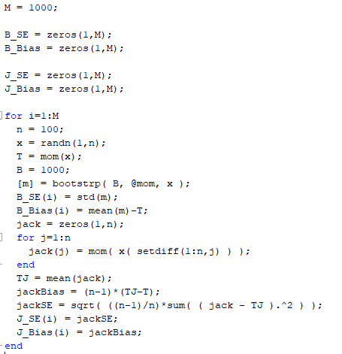

## Results

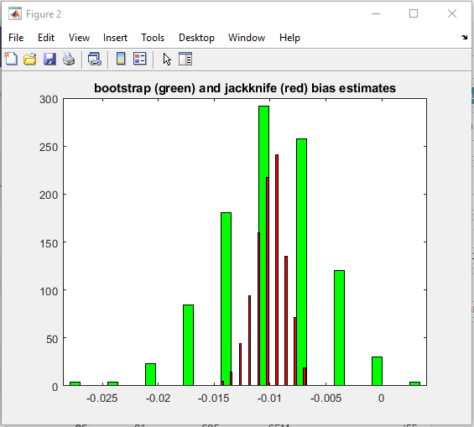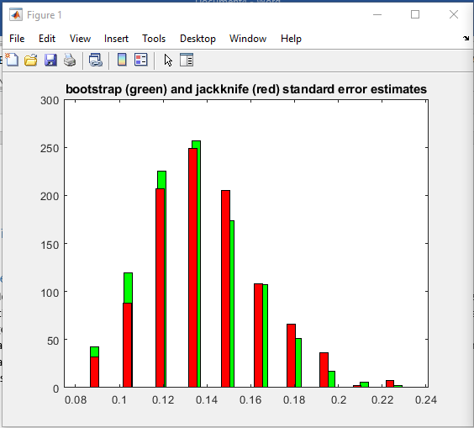

## Discussion

# In Class Assignment

## Problem Statement

Generate data with a random sample of size 100 from Exp(5). Estimate the density of this data using a Normal Kernel and a Epanichikov Kernel. Plot both results.

Use a Monte Carlo simulation to estimate the MSE at a signle point (X = 5).

## Code

KDE

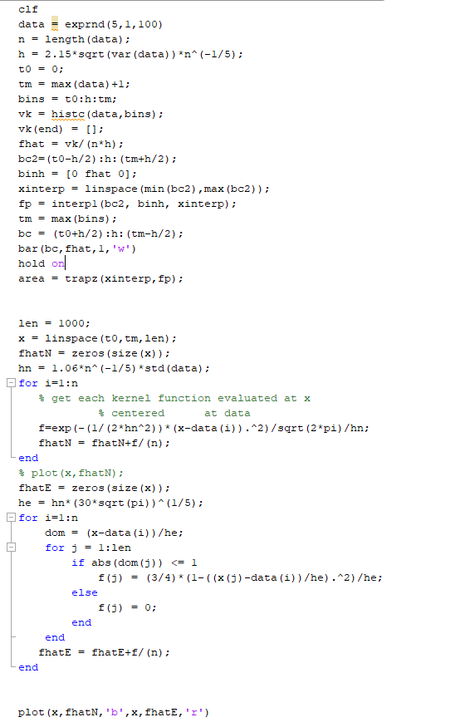

Finding the MSE

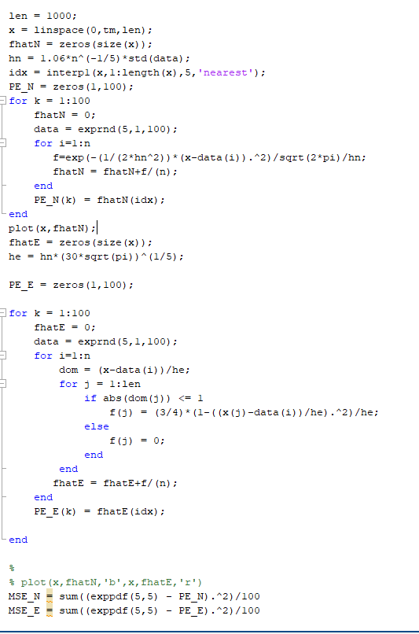

## Results

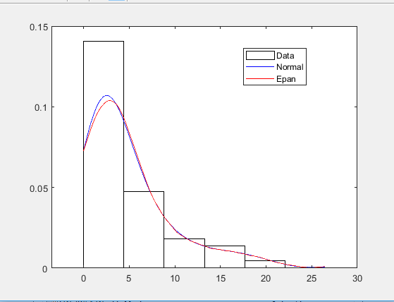

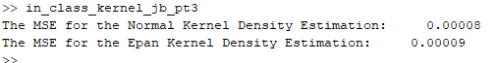

## Discussion

Both of the kernel density estimations, when plotted, resembled an exponential distribution. Because of the adjustment made to the Epan kernel it and the Normal kernel estimation are very similar.

The kernel estimation of the point x = 5 produced values very close to the theoretical density. As a result both MSEs were very low.